Creating a Replicaset

A ReplicaSet’s job is to maintain a stable set of running Pods.

If a Pod crashes or gets deleted, the ReplicaSet automatically creates a new Pod to replace it.
If there are more Pods than desired, it deletes the extra ones.
- A ReplicaSet is a Kubernetes controller that ensures a specified number of identical Pods are running at all times
- A ReplicaSet is a Kubernetes controller that ensures a specified number of identical Pods are running at all times
Objective: Create a Replicaset with three replicas and verify that the pods are running.
Solution:
- Create a YAML file for the Replicaset:
apiVersion: apps/v1
kind: ReplicaSet
metadata:
name: my-replicaset
spec:
replicas: 3
selector:
matchLabels:
app: my-app
template:
metadata:
labels:
app: my-app
spec:
containers:
- name: my-container
image: nginx

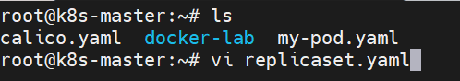
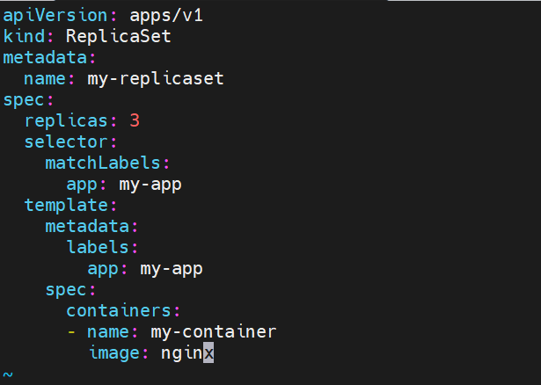
- Apply the YAML file to create the Replicaset:
kubectl apply -f replicaset.yaml

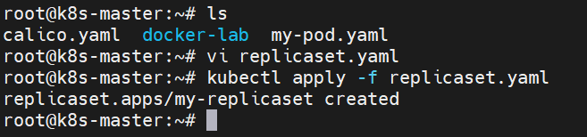
- Verify that the Replicaset and its pods are running:
kubectl get rs
kubectl get pods -l app=my-app

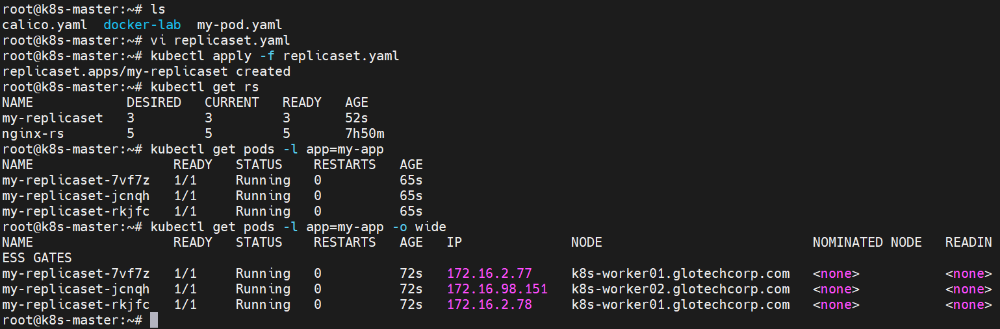

Lab Exercise 2: Scaling a Replicaset
Objective: Scale up a Replicaset to five replicas and verify that the pods are running.
Solution:
- Scale up the Replicaset to five replicas:
kubectl scale rs my-replicaset --replicas=5
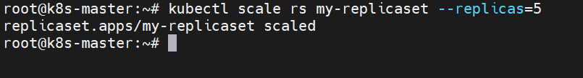
- Verify that the Replicaset and its pods are running:
kubectl get rs
kubectl get pods -l app=my-app

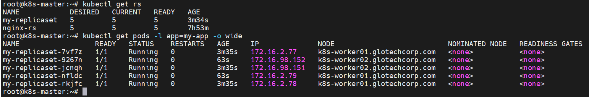

Lab Exercise 3: Updating a Replicaset
Objective: Update the image of a Replicaset and verify that the pods are updated.
Solution:
- Update the image of the Replicaset to nginx:1.19.10:
kubectl set image rs my-replicaset my-container=nginx:1.19.10
- Verify that the pods are updated:
kubectl get pods -l app=my-app -o jsonpath='{range .items[*]}{.spec.containers[0].image}{"\n"}{end}'

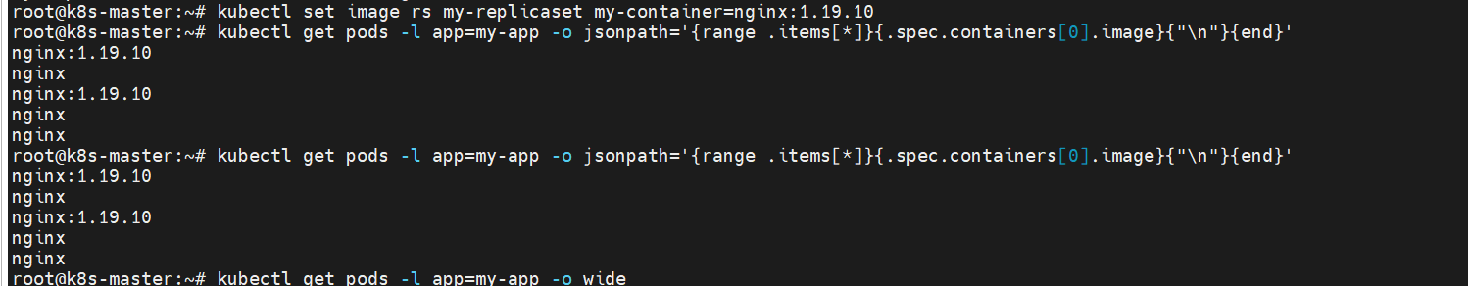
The output should show nginx:1.19.10 for all pods in the Replicaset.
I hope these lab exercises help you learn more about Kubernetes Replicasets! Let me know if you have any questions.

===========================================================================

Lab Exercise 1: Create a Simple ReplicaSet
Objective: Create a ReplicaSet to manage 3 replicas of an nginx pod.
- Task: Define a ReplicaSet manifest for nginx with the name "nginx-rs" and 3 replicas.
Solution:
apiVersion: apps/v1
kind: ReplicaSet
metadata:
name: nginx-rs
spec:
replicas: 3
selector:
matchLabels:
app: nginx
template:
metadata:
labels:
app: nginx
spec:
containers:
- name: nginx
image: nginx:1.14.2

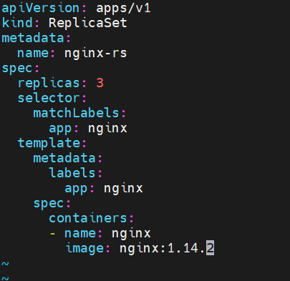

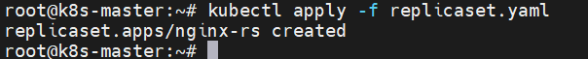

Lab Exercise 2: Update the ReplicaSet
Objective: Update the existing ReplicaSet to use a newer version of the nginx image.
- Task: Update the nginx image version in the ReplicaSet "nginx-rs" to nginx:1.17.9.
Solution:

- Update the ReplicaSet manifest:
# ... (rest of the manifest remains unchanged)
spec:
containers:
- name: nginx
image: nginx:1.17.9
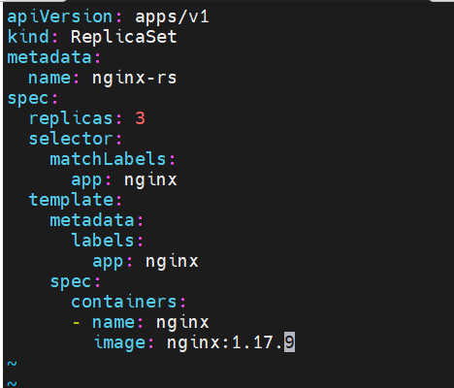
- Apply the changes:
kubectl apply -f [path_to_updated_manifest_file].yaml

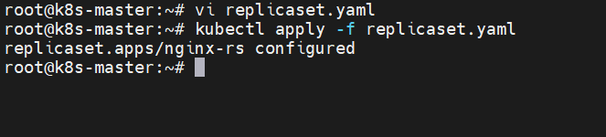

Lab Exercise 3: Scale the ReplicaSet
Objective: Manually scale the "nginx-rs" ReplicaSet to 5 replicas.
- Task: Scale the number of replicas in the "nginx-rs" ReplicaSet to 5 without modifying the manifest file.
Solution: Use the kubectl scale command:
kubectl scale replicaset nginx-rs --replicas=5

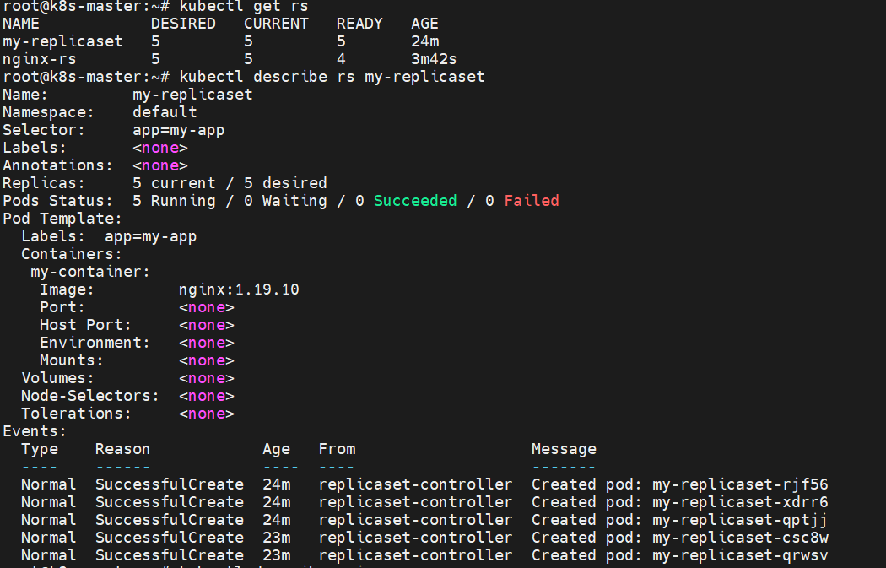

After completing each lab exercise, users can verify their work using kubectl get rs and kubectl describe rs <replicaset-name>.

